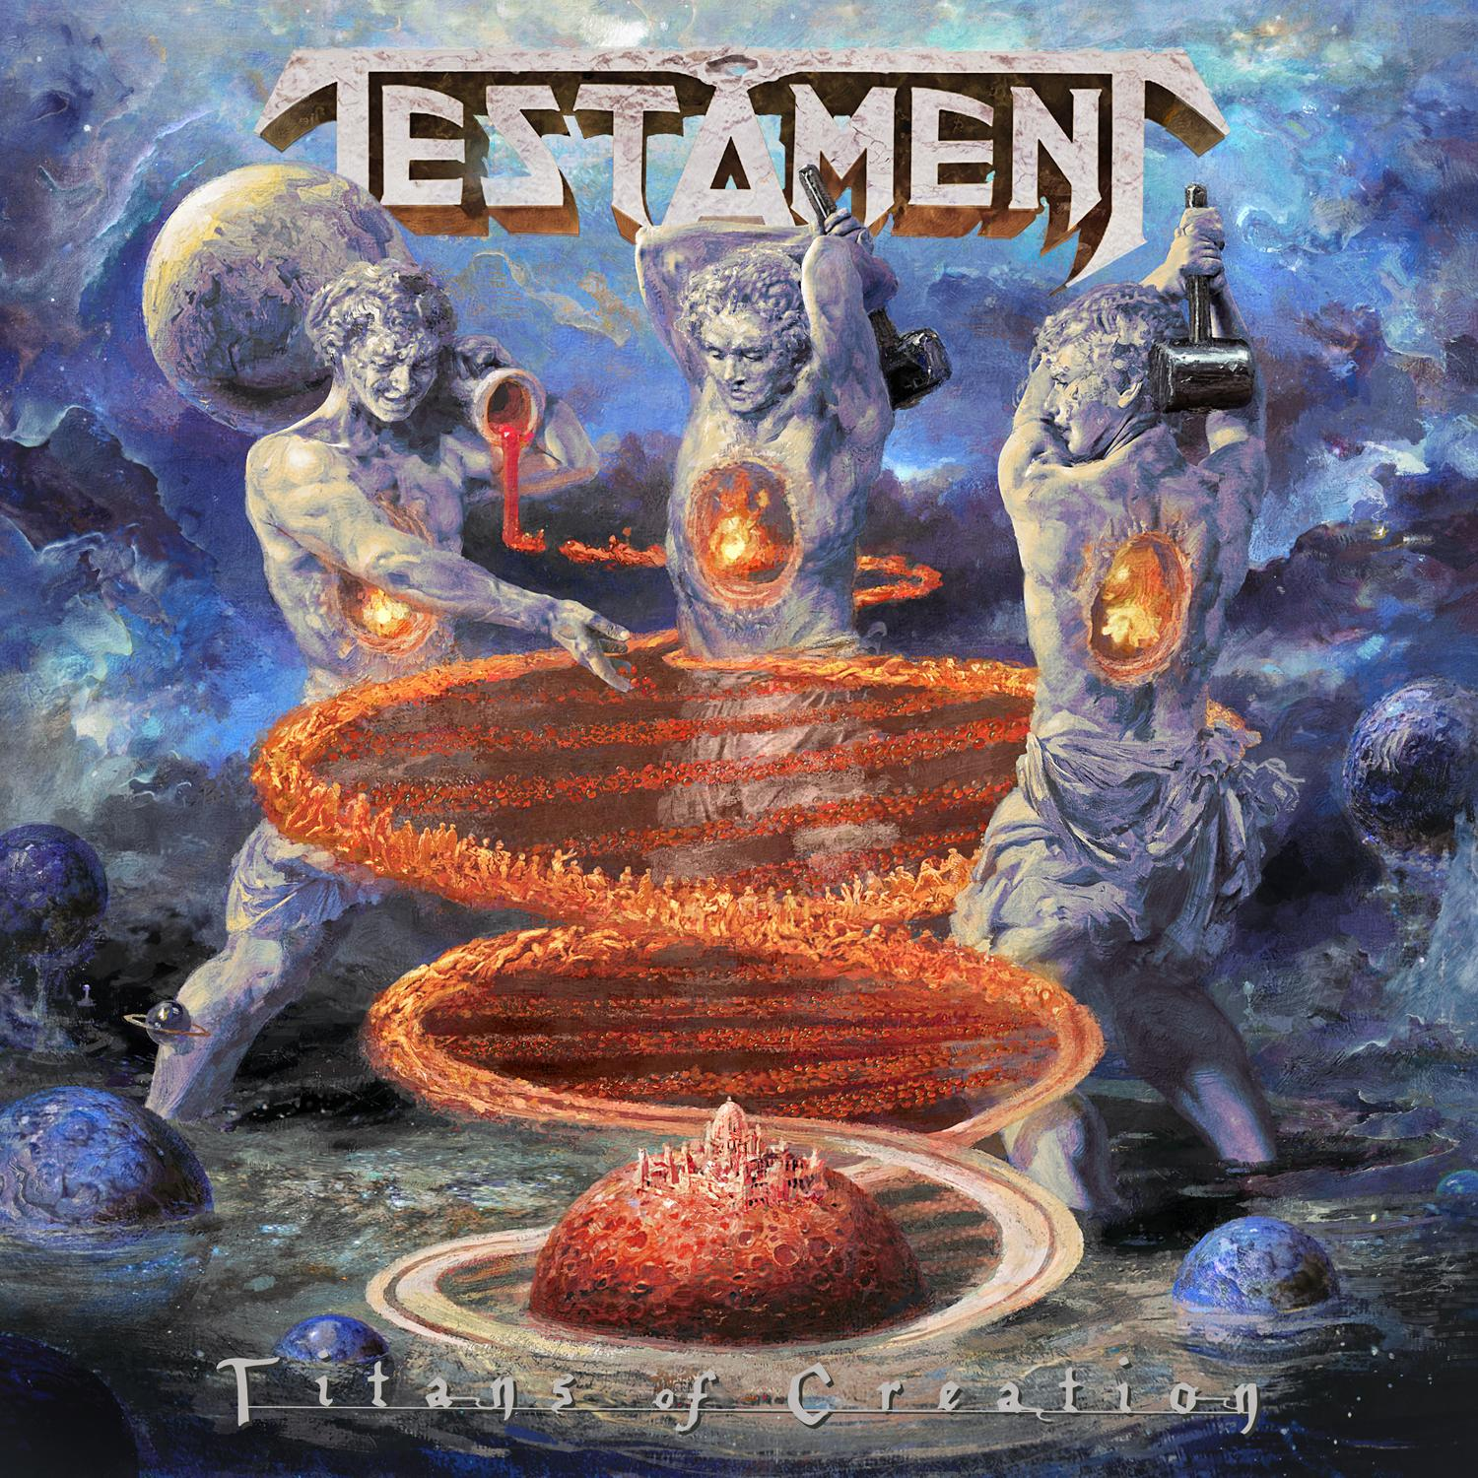

TESTAMENT
»Titans Of Creation«

OUT: 4/03/2020

Line-up: | TESTAMENT online:
Chuck Billy | vocals  Eric Peterson | guitars  Alex Skolnick | guitars  Steve DiGiorgio | bass  Gene Hoglan | drums | www.testamentlegions.us  www.facebook.com/testamentlegions  www.nuclearblast.de/testament

The time has arrived for TESTAMENT to unleash new thunder to the masses and reveal their thirteenth studio album: Titans OF Creation. Just as the elements of this planet thrive within all living creatures, each musician in TESTAMENT represents a necessary component of this latest musical endeavour. Still filled with a massive and unstoppable energy since their last release, TESTAMENT has taken their style to the next level and present an album that is loyal to the roots of traditional thrash metal while still bringing alluring, brilliant, and progressive ingredients to the table. Bass is showcased, new vocals are introduced, and as expected, the guitarwork of Peterson and Skolnick is greatly complex and mesmerizing.

Eliran Kantor stepped up once again to create a new piece of artwork for the cover of this release. His classic, almost Renaissance style of painting melds beautifully with the ancient, psychological, and enlightened subject matter of the songs. Three monstrous titans stand in the place where the planets are formed. One pours molding liquid which the others hammer into human DNA, twisting and turning into the ring of a newborn planet. Each titan has the flame of a dying star burning in their chest; the origin of the atoms making up the bodies that are bubbling and boiling on the curves of the spiraling helix.

Titans OF Creation has many moods and material contained within; all of which somehow tie into a common philosophy of creation and its necessary counterpart: destruction. “Children Of The Next Level” smashes through the gates as the opening track with a flood of sound that prepares the listener for an abundance of violent thrash. Meanwhile, the lyrics rage about the outrageous philosophies of the Heaven’s Gate cult (founded in 1974).

Songs like “Dream Deceiver” carry more old school sound that will tickle the senses of any common TESTAMENT fan. The lyrics describe being trapped in a dream by an otherworldly female force who is slowly working to degrade the mind. Dreams are part of existence, but when we are asleep we are entirely vulnerable; one of the many mysteries of being human. “Someone’s haunting you and won’t leave you alone; the only time they pick at you is at night when they can control the way you sleep,” describes vocalist Chuck Billy.

“Night of the Witch” features frightening and captivating vocals from Eric Peterson. Carrying a vibe far more akin to Black Metal, Peterson swoops in with a power that melds perfectly with Billy’s ground shaking, guttural growls. Taking some influence from Robert Egger’s 2015 horror masterpiece “The VVitch: A New England Folktale,” the song carries with it a magical quality that directly reflects the mood of the film. At the very end of the track, a theremin howls through the air much like witches rising towards the moon; setting the final tone. “The album has a lot about it that’s fresh to the ear,” explains Peterson.

Written by guitarist Alex Skolnick, “Symptoms” is filled with detailed with intricate guitar work that well represents the complicated and spellbinding journey that comes along with handling depression, mood swings, and a countless list of mental health frustrations. The lyrics in this song discuss a sad truth: that mental illness is more common than we all think, and than many of us are willing to acknowledge. On a lighter note, a vibrant track entitled “The Healers” swings back and forth between waves of death and thrash, heavy and melodic, light and dark. The words are spiritual, and extremely personal. They describe Billy’s own experience dealing with all natural medicine men; the elders of the earth, and how they managed to help him pinpoint and heal his past illness. “City Of Angels” comes bearing an entirely new sound for TESTAMENT. The creeping sludgieness and slow, stalking tempo, walk hand in hand with the almost unbelievably gruesome tale of the Nightstalker Richard Ramierz, all combining to form another stand-out track on the record.

In 2020 the days of writing an album all together in one room are far gone, but to be able to take advantage of technology allows for TESTAMENT to go about a very similar writing process to what they always have. Basic songs are molded, structures are added by everyone in the group, instrumentals are highlighted, and finally the lyrics and vocals are created to finalize the sonic story. Facetime and human on human contact still remain crucial elements to TESTAMENT’s song writing process and at some point throughout, every member physically interacts and writes with one another. In between writing this album, the band toured relentlessly which allowed for less stress, more time in between, and greater inspiration for this album cycle. There was also plenty of anxiety-free and level-headed time for pre-production and the initial recording process with Juan Urteaga of Trident Studios. Andy Sneap was then able to tweak, mix, and master this album to his usual perfection.

TESTAMENT’s process of creation has evolved and progressed yet they’ve remained steadfast over the course of literal decades. While always managing to present the genuine aspects of thrash metal that solidify their existence, they spread into unique horizons through developing crisp and fascinating sounds.

